**First Trial**

**1. Download and install APP**

Android users scan the QR code or click [Download]--[[APP(Android)]](http://www.yahboom.net/study/Dofbot-Jetson_nano" \o "" \t "http://www.yahboom.net/study/_blank)to download YahboomRobot APP.

iOS users search"YahboomRobot" in App Store to download APP.

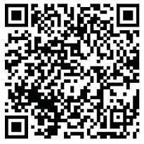

**2. Download and write image file**

2.1 According to this link, **http://www.yahboom.net/study/Dofbot-Jetson_nano**, enter our official website and click [Download]--[Download image], you will get a .zip file.

2.2 Extract the .zip file by 7z software to get an .img file.

2.3 Prepare the card reader and SD card, write the .img file we provided to the SD card, wait patiently for the image to be written.

2.4 Correctly insert the SD card into the card slot of the Jetson NANO board.

**3. Start the DOFBOT**

3.1 Please check the corresponding wiring of the 6 servos and ensure the battery is correctly inserted into the expansion board.

3.2 Open the power switch and wait patiently. When the buzzer whistle three times, which indicates that the DOFBOT has been successfully started.

**4. Connect network and calibration**

4.1 Open YahboomRobot APP, choose [Kit]--[DOFBOT].

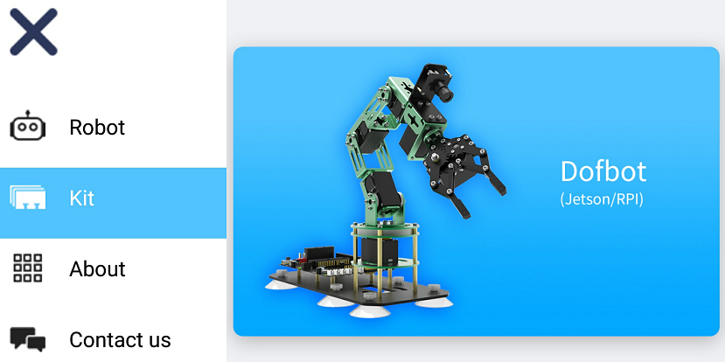

4.2 According to the prompts info on the APP interface, make DOFBOT connect to network.

If you select [Wired connection], please insert the network cable directly into the network cable interface of the Jetson NANO board and we can IP address on OLED. Then, skip to step 4.7.

In this manual, we mainly show how to complete the wireless connection.

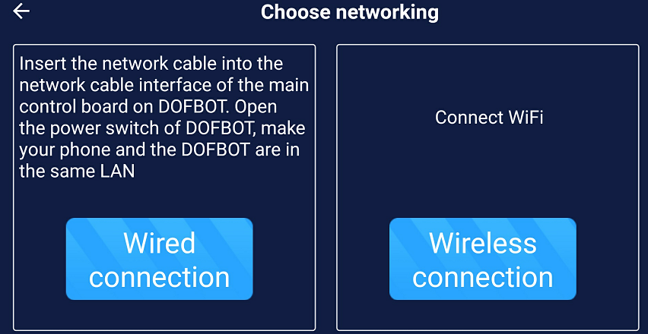

4.3 Long press the K1 button until you hear a whistle, release the button to let the robot enter the network distribution mode. Then, click [next].

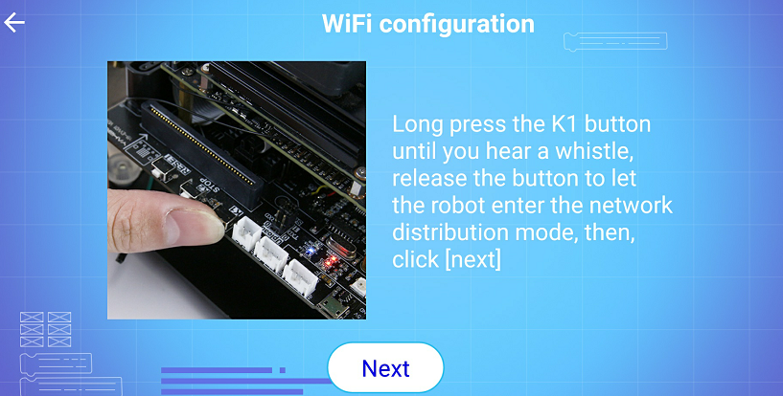

4.4 Then, click [Next]. If the phone need to obtain any permission, please click "ALLOW".

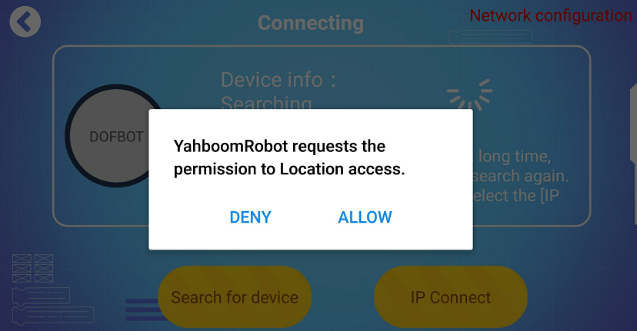

4.5 If the current WiFi name is not displayed or displayed incorrectly, please click [Refresh].

If the WiFi is not currently connected, please click the [WiFi] button to enter WiFi connection interface on your phone.

Then, back to APP and input password of the WiFi connected to the mobile phone, click the [Connect] button to enter the next step.

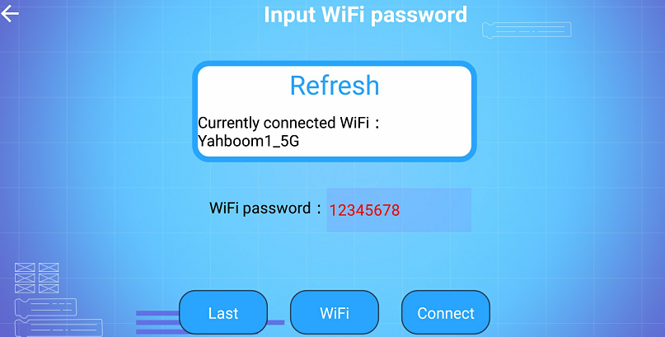

4.6 Scan the QR code on the APP with the camera of DOFBOT. When buzzer whistle 3 times and the blue network indicator light on expansion board keep on, we can click [OK]. We can IP address on OLED.

4.7 The phone will automatically search for the device, and a prompt info will appear after a few seconds, click [Connect]. If the device is not found for a long time, please click [Search for device] to search again.

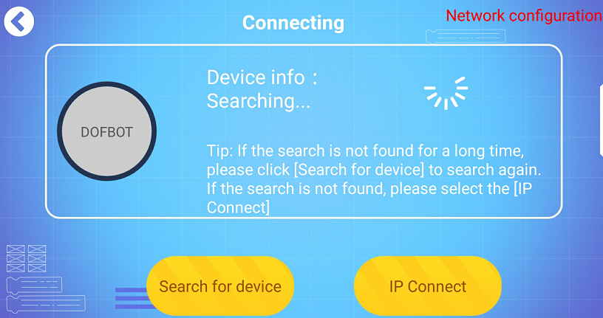

4.8 We can also click the [IP Connect] to connect to the network manually. As shown below, input DOFBOT IP address on APP, “Port”:6000 , “video”: 6500.

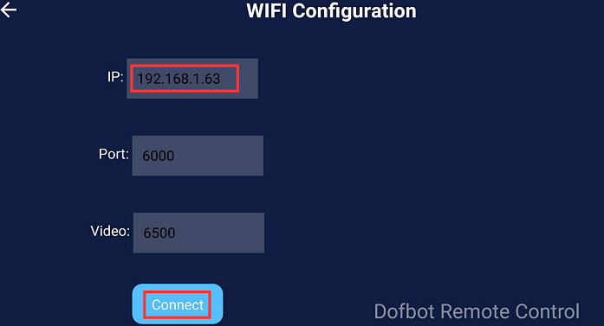

4.9 Guide: DOFBOT calibration. All servos must be calibrated before DOFBOT is used, otherwise it will not work properly. Press the [Middle] button to check whether DOFBOT is in the state of vertical upward, horizontal center, and the mechanical claw is closed. If it is normally, please click the [Skip], otherwise, we need the click [Calibrate] button to calibrate each servo.

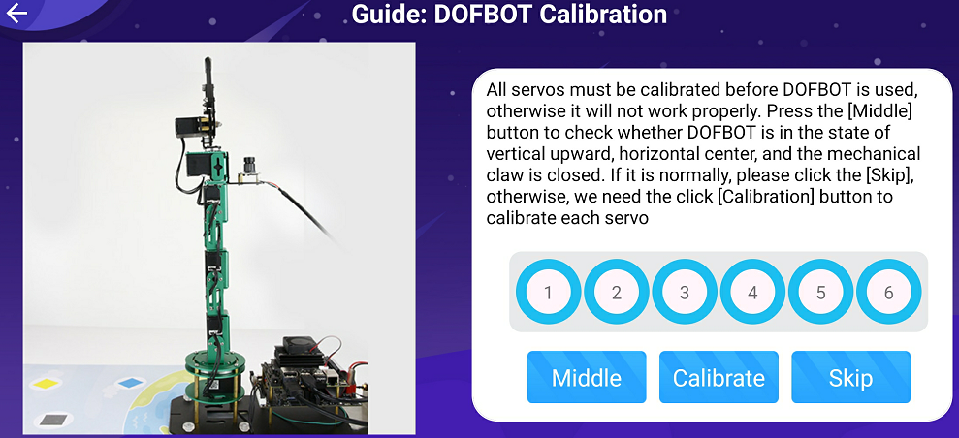

After clicking [Calibrate], DOFBOT will enter the calibration state. Check whether the DOFBOT is in the state of vertical upward, horizontal center, and the mechanical claw is closed. After the adjustment is completed, click [Ok]. If the circle around numbers from blue to green, it means all servos is calibrated successfully, click [Next].

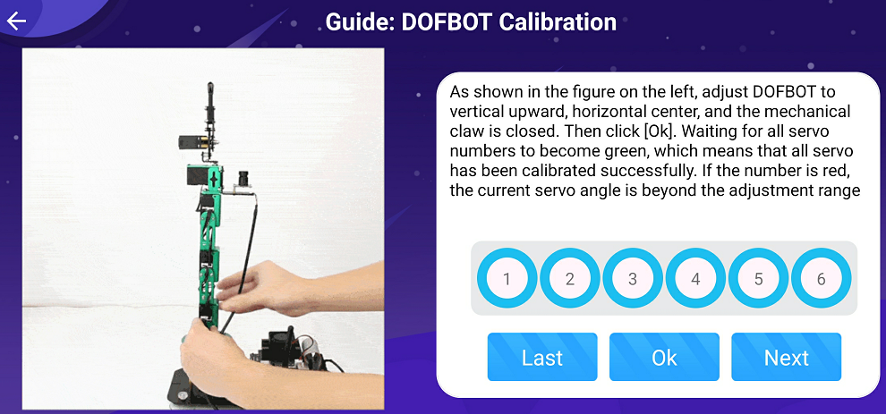

4.10 Guide: Color calibration. Place the red block on the green [wireframe](http://www.baidu.com/link?url=BAiO92fTSaAkpxMXP1W4hHZ3KmdmEilXMTlgRy5eXvTZyscD0V4CIaAtRGVi65YumcwgPjvmOd19mKJ80v-AQEnPPyTowCImDuU4MZuf8c3" \t "https://www.baidu.com/_blank) in the video, ensure that the green [wireframe](http://www.baidu.com/link?url=BAiO92fTSaAkpxMXP1W4hHZ3KmdmEilXMTlgRy5eXvTZyscD0V4CIaAtRGVi65YumcwgPjvmOd19mKJ80v-AQEnPPyTowCImDuU4MZuf8c3" \t "https://www.baidu.com/_blank) can completely cover the red part, and remove your hand. When HSV value remained stable, click [Color Calibration]. Then, we can use the same method to calibrate green, blue, and yellow in sequence. Finally, click [Finish] to end this step.

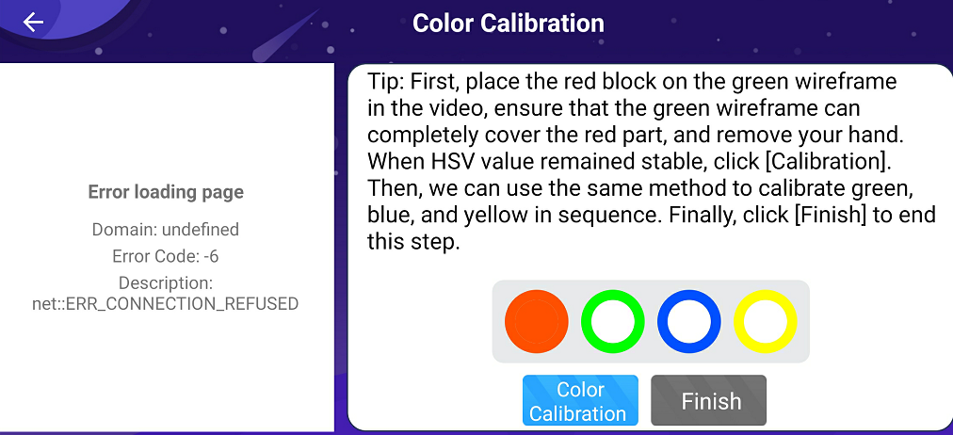

**5. APP control**

**5.1 Remote Control**

Click the **[Remote Control]** icon, the following interface will appear on APP.

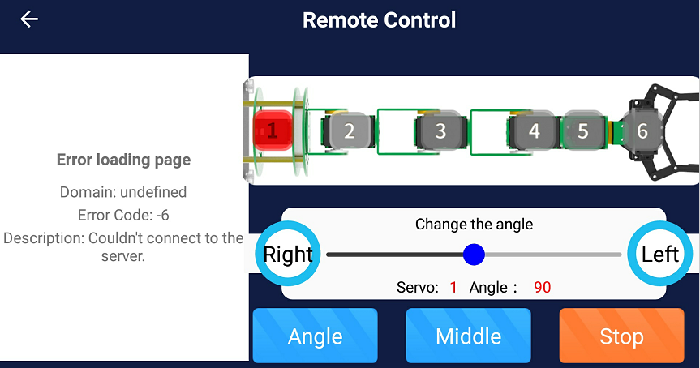

The camera screen is displayed on the left side of the APP. The numbers 1 to 6 on the schematic diagram of the DOFBOT represent the six servos. When we select the servo with the current ID number, the corresponding number will become red. Then, we can adjust the angle of the servo by dragging the slider or pressing left and right buttons.

**[Angle]**: After clicking this button, the APP will read the current servo angle, and update angle value to the upper slider.

**[Middle]**: DOFBOT returns to initial state.

**[Stop]**: Click this button, torque of the DOFBOT will be closed and stop receive control commands. We can manually control the angle of the servo.

Click this button again, torque of the DOFBOT will be opened, it will returns to initial state. And it starts receive control commands.

**5.2 Action Group**

Click the **[Action Group]** icon, the following interface will appear on APP.

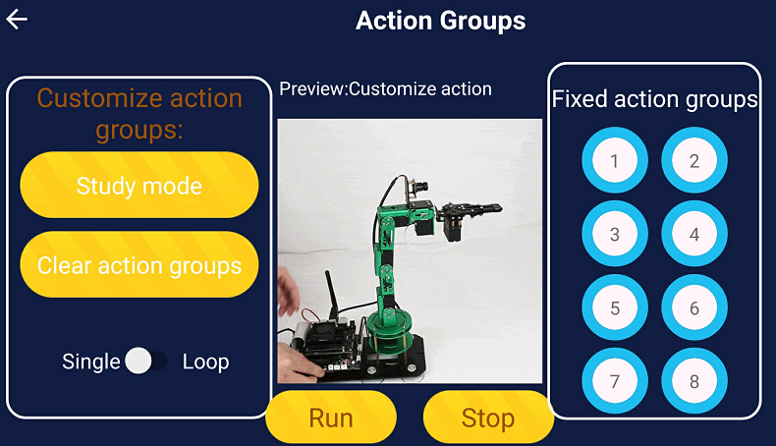

**[Run]**: DOFBOT runs the current action group.

**[Stop]**: DOFBOT stops all actions.

**[Customize action groups]:** Make the DOFBOT learn some action groups. Click [Study mode], a prompt info will pop up, and the RGB light on the extension board will become blue breathing light.

Click **[Record X Action]** button, the DOFBOT will record the current posture as an action group, and the RGB light breathing light on the expansion board will change to another color, which indicating that this action has been recorded. After recording multiple sets of actions, click **[Completed]** to exit this mode, and RGB light on the expansion board will go out.

If RGB light is red breathing light, it means that the study mode is wrong or the recorded action group is full (up to 20 actions are stored), click **[Completed]** button to exit.

**[Fixed action group]:** Click the different number buttons to view the function of the corresponding action group from the preview window. When you click [Run], DOFBOT will run the action group corresponding to the current number.

**5.3 Gesture Interaction**

Click the **[Gesture Interaction]** icon, the following interface will appear on APP.

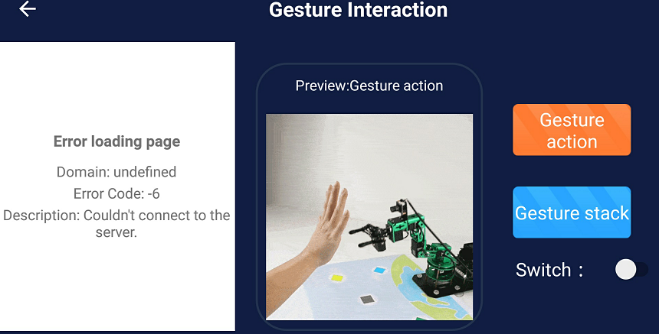

Gesture interaction includes gesture action and gesture stack.

After selecting the corresponding function, click **[Switch]** to open this function, we can see recognized gestures the on preview window. Click **[Switch]** again to closed this function.

**[Gesture action]**: Recognize some gestures and perform corresponding actions.

**[Gesture stack]:** Recognize gesture 1, 2, 3, 4, pick up yellow, red, green, and blue blocks respectively and stack them in order. When the fist is recognized, push down all blocks and the recognition data is reset.

**5.4 Color recognition**

在主界面点击【颜色互动】图标，会出现以下界面。

Click the **[Color recognition]** icon, the following interface will appear on APP.

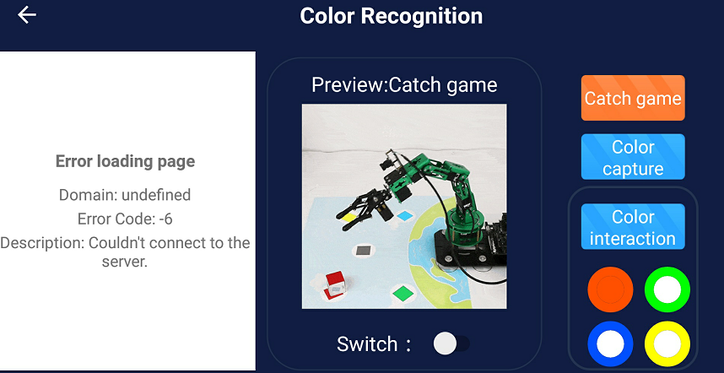

Color recognition includes catch game, color capture and color interaction;

After selecting the corresponding function, click **[Switch]** to open this function, we can see recognized gestures the on preview window. Click **[Switch]** again to closed this function.

**[Catch game]**: Place the block in the area recognized by the camera, DOFBOT will automatically recognize the currently color, and catch the block and put it in the area of the corresponding color on map.

**[Color capture]**: Place the block on the camera, after DOFBOT recognizes the color of the block, it catch the block from the corresponding color area to the middle area on map.

**[Color interaction]**: After selecting the color below, then, open the play switch and place the blocks of the corresponding color in front of the camera of DOFBOT. It will imitate the movement of the snake. The specific phenomenon can be viewed on the preview window.

**5.5 Tracking game**

Click the **[Tracking game]** icon, the following interface will appear on APP.

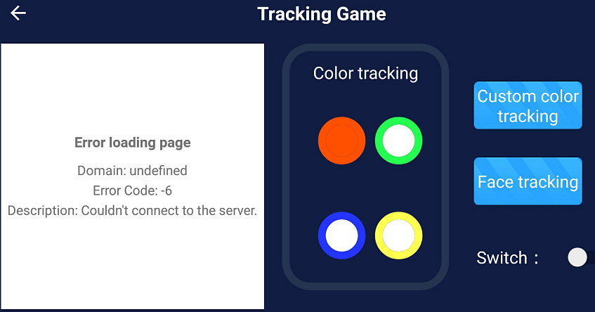

Color recognition includes color tracking, custom color tracking and face tracking;

After selecting the corresponding function, click **[Switch]** to open this function, we can see recognized gestures the on preview window. Click **[Switch]** again to closed this function.

**[Color tracking]**: Select the color on APP, open the switch, and put the block of the corresponding color in front of the camera, move the block, DOFBOT will move with the block.

**[Custom color tracking]**: Click this button, t will display a box on camera video, place the block in the area recognized by the camera. After accurately obtaining the color of the block, open the switch, DOFBOT will move with the block.

**[Face Tracking]**: If a face is detected, DOFBOT will mark it and move with the face.

**6. Garbage Sorting**

Click the **[Garbage Sorting]** icon, the following interface will appear on APP.

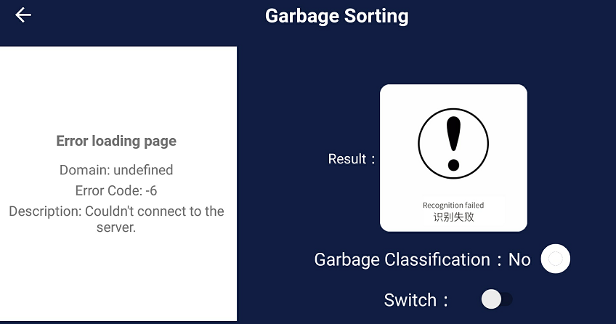

Open the switch and the system will automatically load the model. After the red prompt [Model-Loading...] in the video disappears, place the block with the garbage picture in the area recognized by the camera. DOFBOT can identify the type of garbage on the current block and display result on the APP.

After the same garbage is recognized 10 times continuously, DOFBOT will sort it to the corresponding location on the map according to the garbage category.

**7. Advanced Setting(Beta)**

Click the **[Advanced Setting(Beta)]** icon, the following interface will appear on APP.

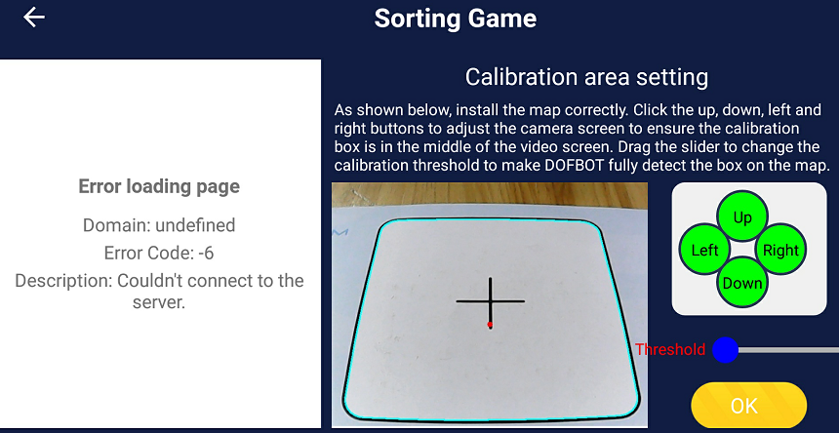

Pressing **[Up, Down, Left, Right]** buttons to move the DOFBOT to make the frame appears completely in the field of view. Then, slide the slider of **[Threshold]** to adjust the frame detection threshold until the four sides of the frame are completely detected, as shown above.

Click [Ok] to enter the [Sorting Game] interface, as shown below.

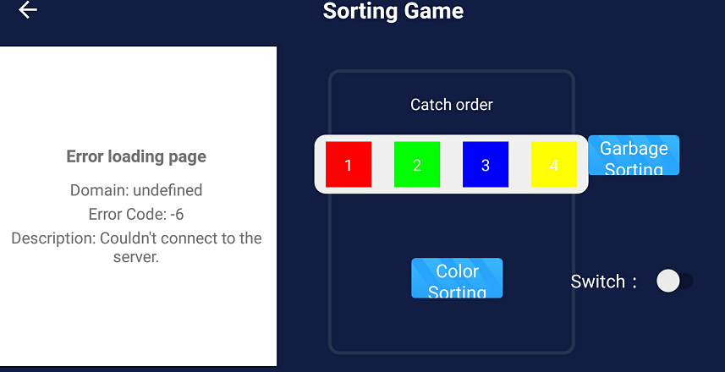

**[Color sorting]**: Click [1], [2], [3], [4] to change the color (black is not selected).

Place different color blocks in the area recognized by the camera, wait for the color to be recognized. Click [Switch] to enable this function

**[Garbage Sorting]**: Click the [Garbage Sorting], wait patiently for the model to load, and then place the block with the garbage picture in the area recognized by the camera. The system will automatically recognize the currently garbage. Click [Switch] to enable this function.

**8.DOFBOT Setting**

Click the **[DOFBOT Setting]** icon, the following interface will appear on APP.

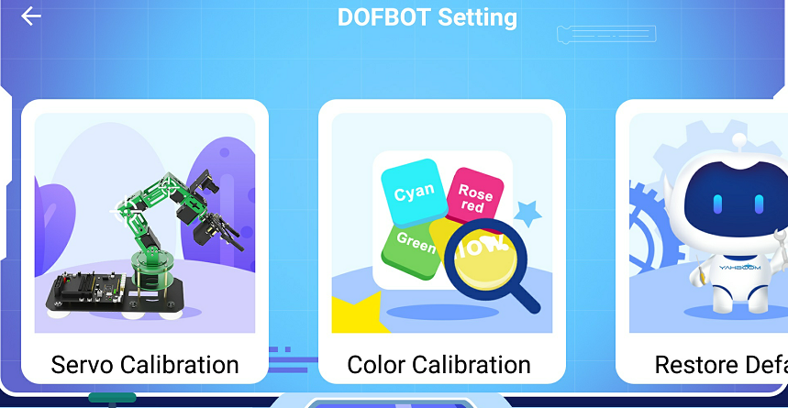

DOFBOT setting includes servo calibration, calibration, and restore the default.

**[Servo Calibration]**: The function is the same as that in the **[Guide: Servo calibration]**.

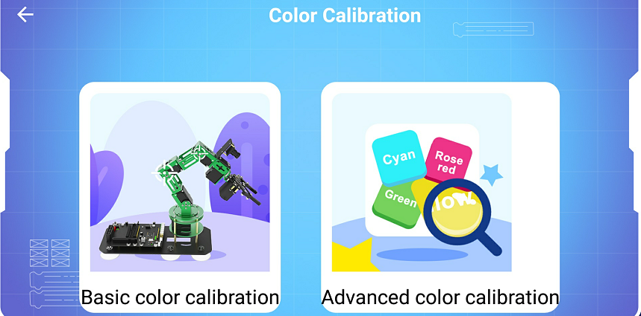

Color calibration includes basic color calibration and advanced color calibration.

**[Basic color calibration]**:The function is the same as that in the **[Guide: Color calibration]**.

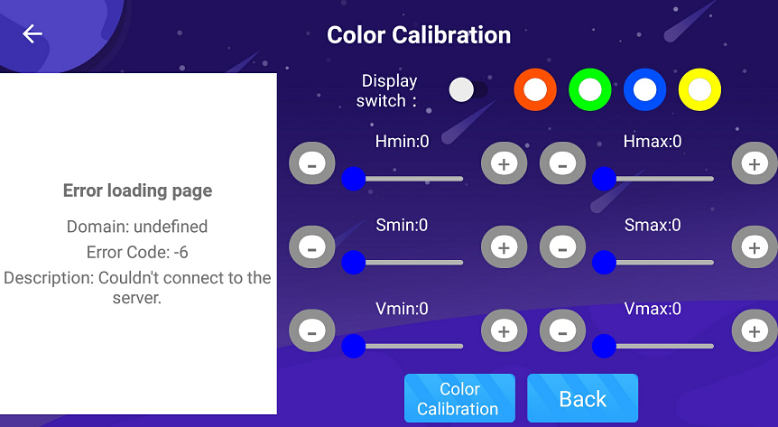

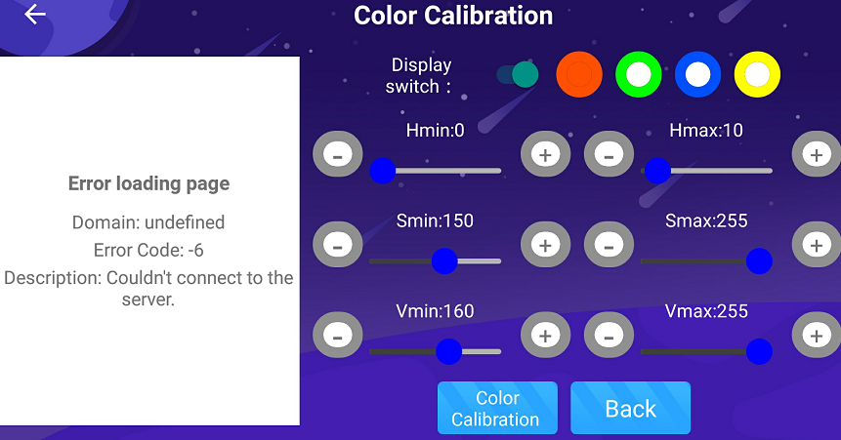

[Advanced color calibration]: Place four color blocks in the field of view at the same time, select the color that needs to be calibrated. Then, click the [display switch] button to view the black and white image, and adjust through the HSV slider until it is not detected others colors. Next, click [Color Calibration] to complete the calibration of this color, and calibrate other colors in the same way. Finally, click [Finish] to end this step.

For details, please see the course [Al Vision Course]--[Color Calibration].

**[Restore default]**: Clear the configuration information of the APP.